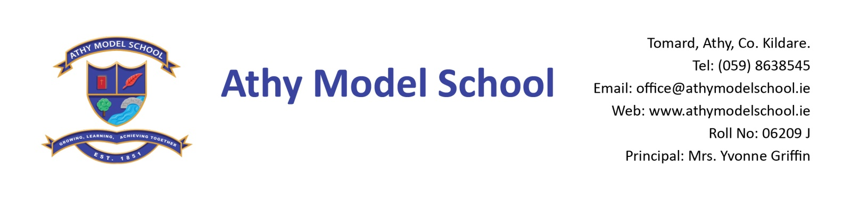

01/06/2016

Dear Parents,

The following is the agreed report from the Board of Management meeting on Wednesday 1st June:

**Agreed Report BOM Meeting Weds 1st June**

* Anonymous Drumcondra results in Reading and Maths for 2nd, 4th and 6th classes were presented to the Board.
* Next year’s school calendar was ratified by the Board. School will reopen for pupils on Tuesday 30th August 2016. A copy of the school calendar will be posted to all families on Mon 13th June, along with school reports and book lists for next year.
* The End of Year service will take place on Sunday 19th June. Our SNA, Concepta Davidson, will be leaving the Model School after eighteen years, and there will be a presentation made to her at this service. Attendance awards and other prizes will also be presented. We encourage all families to attend.
* David Day will be doing drumming workshops with the pupils next Weds 8th June. Pupils are asked to contribute €2 each, to be given to their teacher on or before Weds.
* Please note that our swimming slot for next year has changed. Swimming will take place at 11 am on Mondays in September-December, and all pupils, including infants, will return to school on the bus at 12 noon. Further details re swimming will follow at the beginning of September.
* A reminder that school is closed on Monday for the bank holiday and on Tuesday to facilitate staff training in the new Primary Language Curriculum. School will reopen on Wednesday 8th June.

**Upcoming dates for your diary:**

Weds 8th June: Drumming Day

Fri 10th June: Children’s Festival and Sports Day, Blessington, Co. Wicklow

Mon 13th June: Infant Induction 1.30-2.20 pm

Tues 14th June: Junior school Tour to Castlecomer. 3rd to 6th class will take part in a Willow Weaving Workshop with artist Beth Murphy.

Weds 15th June: Senior School Tour to Sandyford Jump Zone

Sun 19th June: End of year Service, St. Michael’s Church

Fri 24th June: 6th Class Sale

Please refer to your letters for further details about the above activities.

Wishing you all a lovely bank holiday weekend.

___________________

Yvonne Griffin