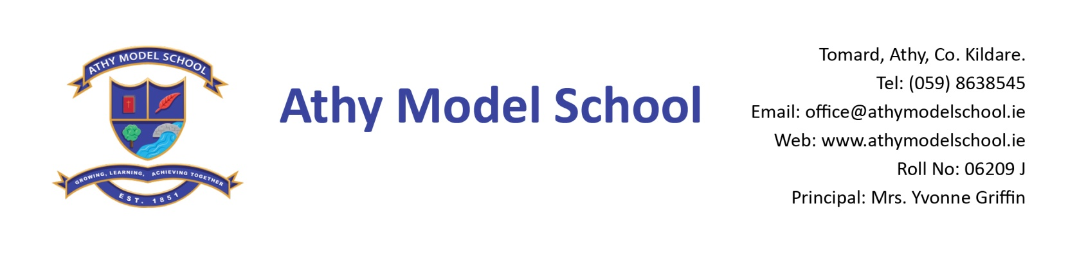
4th Class Booklist 2018-2019
English
Treasury- Core Skills Activity Book C (Folens)
Just Handwriting 4th Class (educate.ie)
Spell Well 4 (C.J. Fallon)
Mini dictionary (Collins or Oxford)

Gaeilge
Fuaimeanna agus Focail Rang 4 (Folens)
Seo Leat 3 (C.J. Fallon)
Irish mini Dictionary (Collins)

Maths
Mathemagic 4th Class (C.J. Fallon)
New Wave Mental Maths Workbook 4th class (Prim-Ed)
Tables Book (please keep your tables book from last year)
Calculator

SESE
History Quest 3 (C.J. Fallon)
Geography Quest 3 (C.J. Fallon)
Atlas: Modern Atlas for Irish Primary Schools (Folens) – use atlas from 3rd Class

Homework Journal: C.J. Fallon
PE: Non marking runners
Art: Old shirt
Copies :Please note: The school will supply all copies this year. The cost will be included in requisites.
Resources : Long ruler, pencils, markers, colouring pencils, rubbers, sharpeners
Blue Frixion erasable pen – to be replaced when needed. (Available from Tesco & Easons)
3 Pritt sticks: to be replaced by home when necessary
Set of whiteboard markers (for pupil whiteboards) – to be replaced when needed.
Hand towel labelled with your child’s name
Folder (Ring Binder), dividers, 20 poly pockets, 2 x A4 zip mesh wallets
Reusable drinks container
Please write your child’s name in pencil on all textbooks and label all other items with name. Pupils will label all copies in September. Please label school sweaters & polo shirts clearly with your child’s name.
A letter requesting payment of the following will be sent out in September and there will be a facility for paying online if you have given the school your email details. You will have the option of paying in termly instalments. Please wait until you receive this letter before sending in any money:
- Requisites-€35 (approx) (art, photocopying etc.)
- Voluntary contribution - €50
- Swimming-€50 (approx)
- Insurance-€5/€8 (approx)
- Reader/novel rental - €8

