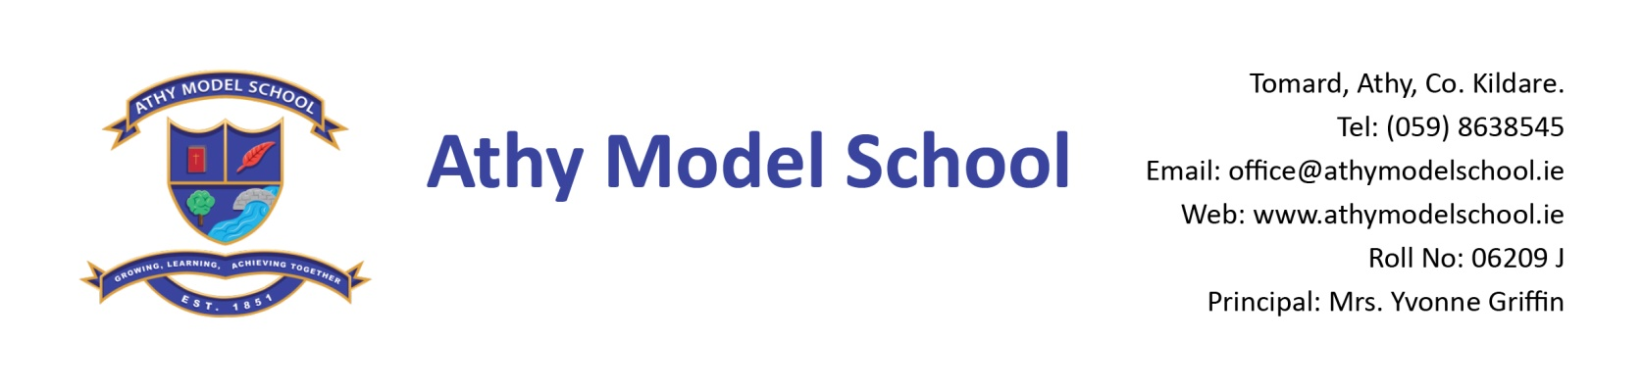
Book Rental Scheme- 6th Class Booklist 2018-2019
English
Spell Well 6 (C.J. Fallon)

Gaeilge
Sin é 6 & Mo Scór 6 (EDCO)
Fuaimeanna & Focail- Rang a Sé (Folens)

Maths
New Wave Mental Maths 6th class (Prim Ed)
Tables Book (Fallons) – use book from 5th Class
Geometry set
Calculator

Homework Journal: Fallons

PE: Non-marking runners only
Art: Old shirt

Please note: The school will supply all copies this year. The cost will be included in requisites.

1 USB Memory Stick (For project work etc. – any size)
Blue, black and red Frixion erasable pens – to be replaced when needed. (Available from Tesco & Eason’s)
Set of whiteboard markers (for pupil whiteboards) – to be replaced when needed.
1 Ruler (non-shatter), pencils, markers, colouring pencils, 3 Pritt sticks
1 Ring binder Folder, poly pockets, dividers, address labels
2 A4 zip mesh wallets
A4 foolscap lined paper
A reusable drinks container (fruit juice cartons not allowed)
Labelled hand towel in a bag

Please name all textbooks in pencil only. Pupils will label their copies with address labels in September.
A letter requesting payment of the following will be sent out in September and there will be a facility for paying online if you have given the school your email details. You will have the option of paying in termly instalments. Please wait until you receive this letter before sending in any money:

Requisites - €35 approx (art, photocopying)
Voluntary Contribution - €50 per pupil
Swimming - €50 (approx)
Insurance - €8 / €5
Reader rental - €8

Please label school sweatshirts & polo shirts clearly with child’s name.

