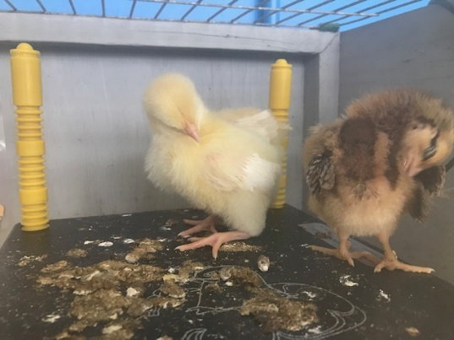
May 2019 Newsletter
Incubator Our incubator arrived from Nore Valley Park on 13 th March. There was great excitement amongst the pupils and staff as six new chicks hatched! 5th and 6th also had an incubator in their room and some of their chicks hatched too.

The pupils in all classes treated their parents and friends to a fabulous recital of tin whistle tunes, singing and drama on Thursday 11th April. It was amazing. Well done to pupils and teachers for all the work they put in and thank you to parents for supporting it.
Table Quiz
A huge thanks to everyone who supported our recent fundraising table quiz for the school. Sincere thanks to our Parents’ Association for all their hard work in organising the event. In total over €1550 was raised.
Green Schools
Congratulations to the Green School’s Committee and all the pupils and staff in the school for gaining their third green flag. Well done everyone. A special thank you also to Mrs. Deane for all the additional work in organising the Green School’s Committee.
Easter Egg Hunt
The Easter Bunny was very busy on 12th April hiding eggs in the school grounds and Junior and Senior Infants with the help of 6th Class had a very exciting and enjoyable egg hunt. Thank you Easter Bunnies!

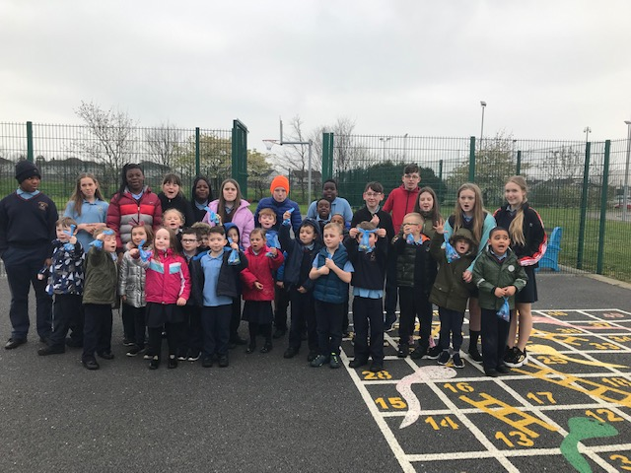
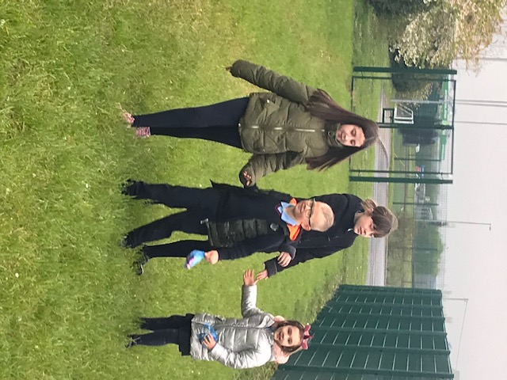

Darkness into Light We hope that many of our staff and parents will join the town community in this 5 km walk which takes place in Athy , starting at 4.15 am (!!) on Saturday 11th May in aid of Pieta House. Anyone interested will need to register online.
Tag rugby ended on Monday 8th April and we would like to say a big thank you to Tadhg Kelleher for all his time and dedication in giving tuition pupils in 1st to 6th classes this year.
Tennis will be starting Wed. 15th May. The first two sessions will be on Wednesdays and the next four sessions will be on Tuesdays.
We will soon be practising for the West Glendalough Children’s Festival and Sports Day which takes place this year in Donoughmore this year on Friday 7th June. Although school is closed on this day, all pupils are expected to attend this service and sports day. It is a wonderful day out for the whole family.
Our Induction afternoon for new pupils and their parents takes place on Wednesday 19th June, from 1.40 to 2.20 pm. This is a great opportunity for new pupils and their parents to meet each other, see the school, and spend some time in what will be their home from home for the next eight years!

The Junior School Tour for infants, 1st and 2nd class will take place this year on Wednesday 12th June. The Senior School Tour for 3rd, 4th, 5th and 6th class is on Monday 17th June. Further details will follow soon.
Children will be involved in a drumming workshop run by David Day in June.

Our End of Year service takes place on Sunday 23rd June in St. Michael’s Church. This is where we say goodbye to our 6th class pupils and the attendance and other prizes are awarded. We encourage all families to attend this service.

The 6th Class Sale takes place on Monday 24th June this year. Everyone is welcome.
School closes on Wednesday 26th June for the summer holidays and we will be closing early.

