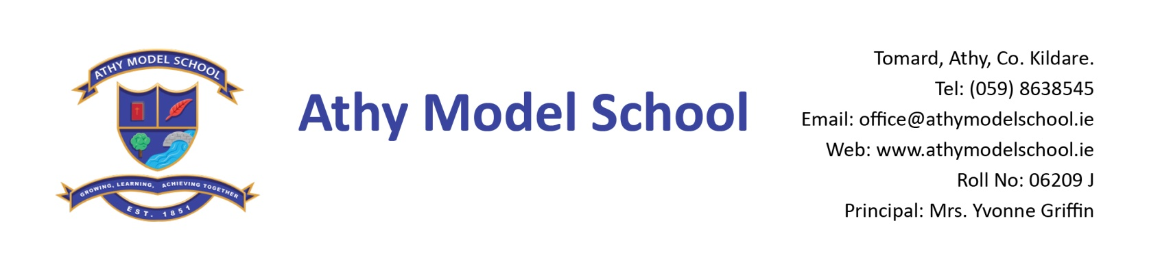

1st Class Book List 2019/2020

English
New Treasury 1 (Folens 2018)
Just Handwriting Cursive Senior Infants (educate.ie) - this programme is based on the premise that children have done cursive writing from Junior Infants.
First class are beginning cursive writing next year and will need a Senior Infants book first to learn how to do the cursive letters
Just Phonics 1st class (educate.ie)

Irish
Céim ar Chéim Rang a haon (C.J.Fallon) (Please buy text book only)

Maths
Busy at Maths 1 (CJ Fallon
Work it Out 1st class (educate.ie)
Tables Champion 1st Class (educate.ie)
Tables book (C.J. Fallon)

Homework Journal C.J. Fallon’s Homework Journal
Copies
Please note: the school will supply all copies this year. You will be billed for them in September.
Resources
2 A4 zipped plastic wallets (Mesh only)
1 A4 cardboard wallet
2 B5 zipped mesh folder
1 safety scissors
Long ruler, pencils, colouring pencils, rubbers, sharpeners, pencil case
2 Pritt sticks: to be replaced by home when necessary
3 whiteboard markers (to be used by children in school on mini whiteboards)
Reusable drinks container (disposable fruit juice cartons not allowed)
Hand towel (labelled) in a bag

PE
Non- marking trainers for PE.

Art
Old adult sized t-shirt for Art

Please name all textbooks in pencil only on inside cover. Please label all items of clothing and pencils /colouring pencils etc clearly with your child’s name.
A letter requesting payment of the following will be sent out in September and there will be a facility for paying online if you have given the school your email details. You will have the option of paying in termly instalments. Please wait until you receive this letter before sending in any money:

- Copies-€5
- Requisites-€35 (art, photocopying)
- Voluntary Contribution-€50 per pupil
- Swimming-€50 approx
- Insurance-€5/€8 approx
- Reader/novel rental-€8

