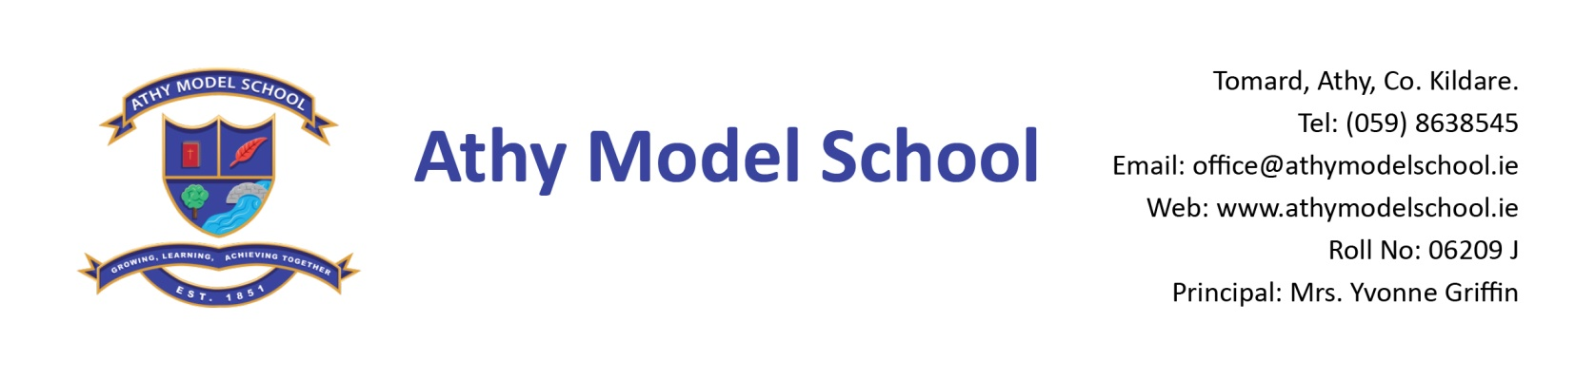
3rd Class Booklist 2019-2020
English
Lift Off! – Rainbow English Programme - Stage 3, Book 2 (C.J. Fallon) Please buy the pack
Just Handwriting 3rd Class (educate.ie)
Spell Well 3 (C.J. Fallon)
Mini dictionary (Collins or Oxford)

Gaeilge
Fuaimeanna agus Focail - Rang 3 (Folens)
Seo Leat 4 (C.J. Fallon)
Irish Mini Dictionary (Collins)

Maths
Mathemagic 3rd Class (C.J. Fallon)
New Wave Mental Maths Workbook 3rd class (Prim-Ed)
Tables Book (please keep your tables book from last year)
Calculator

SESE
History Quest 4 (C.J. Fallon)
Geography Quest 4 (C.J. Fallon)
Atlas: Philips Modern Atlas for Irish Primary Schools (Folens)

Homework Journal: C.J. Fallon

PE Non marking runners. Also, a spare/ old pair of runners to be kept in school.

Art Old shirt

Copies Please note: The school will supply all copies this year. The cost will be included in requisites.

Resources:
Long ruler, pencils, markers, colouring pencils, rubbers, sharpeners
3 Pritt sticks: to be replaced by home when necessary
Set of whiteboard markers (for pupil whiteboards) – to be replaced when needed.
Hand towel labelled with your child’s name.
Safety scissors labelled with your child’s name
Folder (Ring Binder), dividers, 20 poly pockets, 2 x A4 zip mesh wallets, address labels.
Reusable drinks container
Please write your child’s name in pencil on all textbooks and label all other items with name. Pupils will label all copies in September. Please label school sweaters & polo shirts clearly with your child’s name. A letter requesting payment of the following will be sent out in September and there will be a facility for paying online if you have given the school your email details. You will have the option of paying in termly instalments. Please wait until you receive this letter before sending in any money:

- Requisites-€35 (approx) (art, photocopying etc.)
- Voluntary contribution - €50
- Swimming-€50 (approx)
- Insurance-€5/€8 (approx)
- Reader/novel rental - €8

