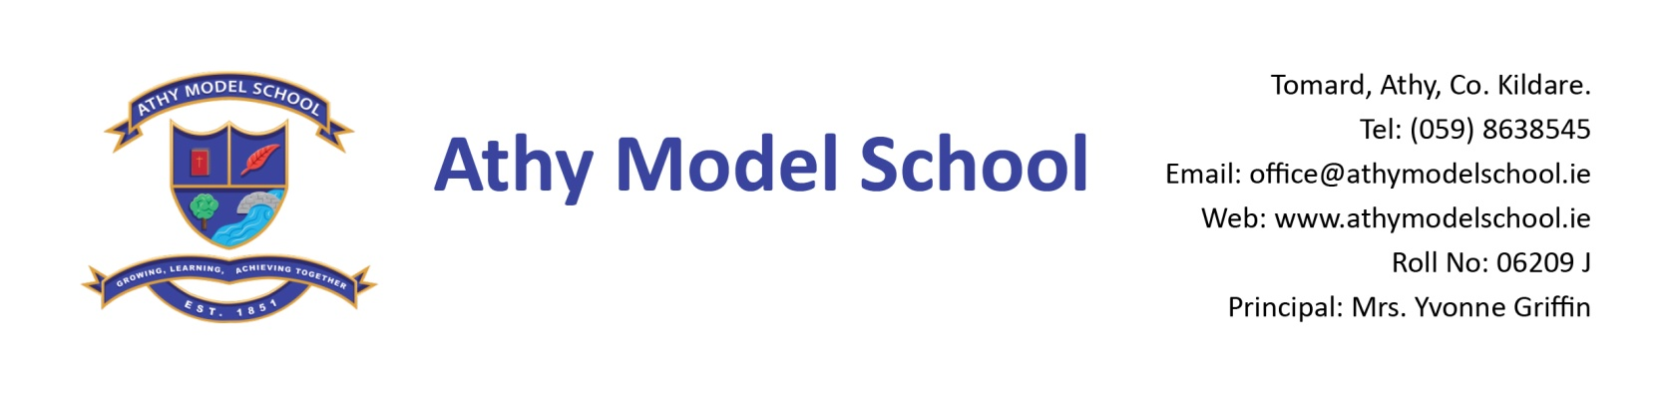
Book Rental Scheme- 3rd Class Book List 2019-2020
English
Spell Well 3 (C.J. Fallon)

Gaeilge
Seo Leat 4 (C.J. Fallon)
Fuaimeanna agus Focail - Rang 3 (Folens)

Maths
New Wave Mental Maths Workbook 3rd Class (Prim Ed)
Tables Book (Please keep from last year)

Homework Journal: C.J. Fallon

PE: Non marking trainers. Also, a spare/ old pair of runners to be kept in school.

Art: Old shirt

Copies
Please note: The school will supply all copies this year. The cost will be included in requisites.
Resources
Long ruler, pencils, markers, colouring pencils, rubbers, sharpeners
3 Pritt sticks: to be replaced by home when necessary
Set of whiteboard markers (for pupil whiteboards) – to be replaced when needed.
Hand towel labelled with your child’s name.
Safety scissors labelled with your child’s name
Folder (Ring Binder), dividers, 20 poly pockets, 2 x A4 zip mesh wallets, address labels
Reusable drinks container

Please write your child’s name in pencil on all textbooks and label all other items with name. Pupils will label all copies in September. Please label school sweaters & polo shirts clearly with your child’s name.
A letter requesting payment of the following will be sent out in September and there will be a facility for paying online if you have given the school your email details. You will have the option of paying in termly instalments. Please wait until you receive this letter before sending in any money:

- Requisites-€35 (approx) (art, photocopying etc.)
- Voluntary contribution - €50
- Swimming-€50 (approx)
- Insurance-€5/€8 (approx)
- Reader/novel rental - €8

