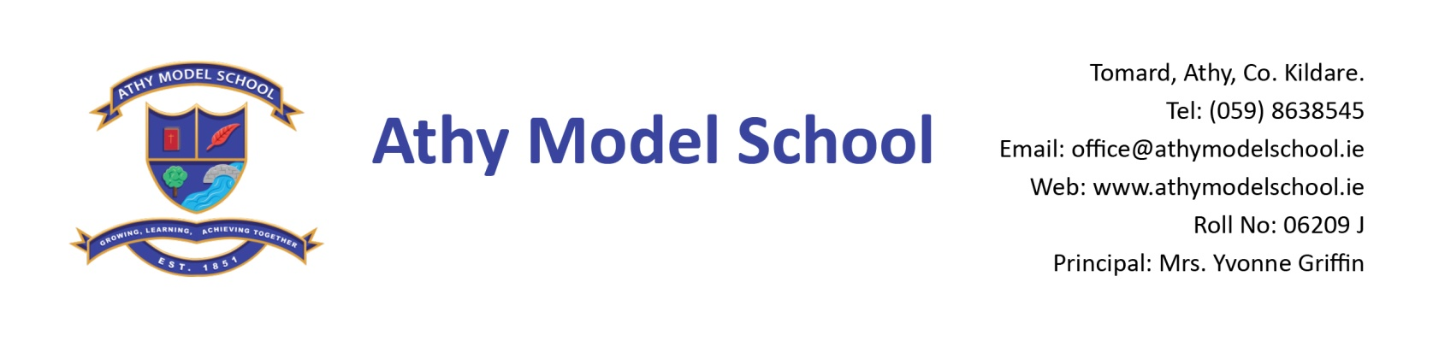
Book Rental Scheme: 4th Class Book List 2019-2020
English
Spell Well 4 (C.J. Fallon)

Gaeilge
Rírá 4 (C.J. Fallon)
Seo Leat 4 (C.J. Fallon)

Maths
New Wave Mental Maths Workbook 4th class (Prim-Ed)
Tables Book (please keep your tables book from last year)
Calculator

Homework Journal: C.J. Fallon

PE Non- marking runners. Also, a spare/ old pair of runners to be kept in school.

Art Old shirt
Copies
Please note: The school will supply all copies this year. The cost will be included in requisites.
Resources
Long ruler, pencils, markers, colouring pencils, rubbers, sharpeners
Blue Frixion erasable pen – to be replaced when needed. (Available from Tesco & Easons)
3 Pritt sticks: to be replaced by home when necessary
Set of whiteboard markers (for pupil whiteboards) – to be replaced when needed.
Hand towel labelled with your child’s name
Safety scissors labelled with your child’s name
Folder (Ring Binder), dividers, 20 poly pockets, 2 x A4 zip mesh wallets, address labels
Reusable drinks container

Please write your child’s name in pencil on all textbooks and label all other items with name. Pupils will label all copies in September. Please label school sweaters & polo shirts clearly with your child’s name.
A letter requesting payment of the following will be sent out in September and there will be a facility for paying online if you have given the school your email details. You will have the option of paying in termly instalments. Please wait until you receive this letter before sending in any money:

- Requisites-€35 (approx) (art, photocopying etc.)
- Voluntary contribution - €50
- Swimming-€50 (approx)
- Insurance-€5/€8 (approx)
- Reader/novel rental - €8

