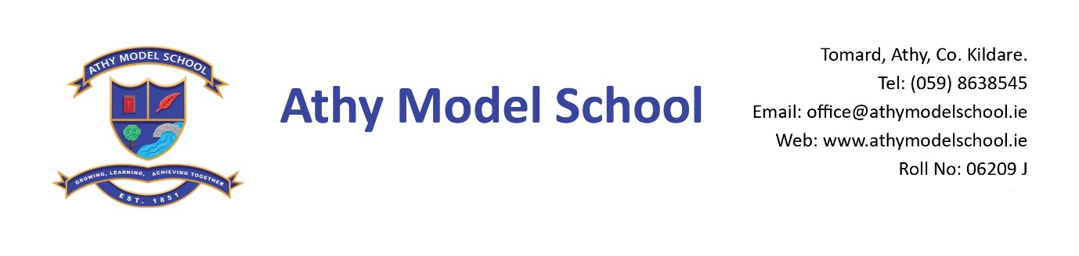
Senior Infant Booklist 2018/2019
English
Over the Moon: Skills Book Senior Infants (Gill)
Just Handwriting: Pre-cursive Handwriting programme for Senior Infants (educate.ie)
Just Phonics Senior Infants (educate.ie)

Maths
Busy at Maths Senior Infants (CJ Fallon)

Please supply:
3 A4 zip wallets (mesh only)
2 A4 document folders
1 B5 zip wallet (mesh only)
1 A4 drawing book (spiral bound only) Junior Infant drawing book can be used from last year
Pencil Case (one where pencils can be placed in easily & quickly!)
Junior Grip handwriting pencils
Junior Grip colouring pencils or twistables
Erasers, sharpeners
2 large Pritt sticks
2 Whiteboard markers (to be used by children on school mini whiteboards & replenished when needed)

An old adult sized t-shirt for Art (no buttons!)
Labelled hand towel (that can be hung on classroom hooks)
Reusable drinks container (disposable fruit cartons are not allowed eg: Capri Sun)

Please
Label all of the above clearly with child’s name (including colouring pencils)
Name all textbooks in pencil only on inside cover.

A letter requesting payment of the following will be sent out in September
Copies: €5
Requisites: €35 approx (art, photocopying)
Voluntary Contributions: €50 approx
Swimming: €50 approx
Insurance: €5/€8 approx
Reader Rental: €5

You will have the option of paying in termly instalments. Please wait until you receive this letter before sending in money.

