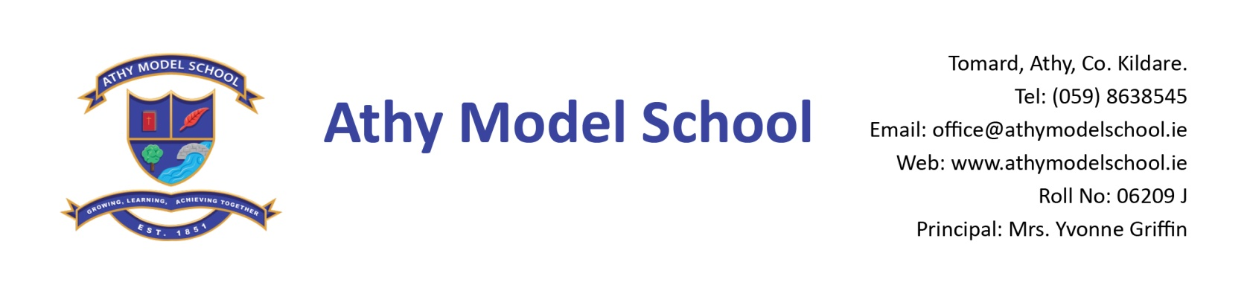

1st Class Book List 2022-2023

English
Over the Moon: Skills Book 1st Class (Gill)
Sounds Like Phonics Activity Book C (CJ Fallon)
Just Handwriting: Cursive Handwriting programme for Senior Infants (educate.ie) -
(We begin cursive writing in 1st class, therefore they use the Senior Infant Workbook. Senior Infants use the Pre-cursive programme)

Irish
Bua na Cainte 1 (Edco)

Maths
Busy at Maths 1 (CJ Fallon)
Work it Out 1st class (educate.ie)
Tables book (C.J. Fallon)

Copies: The school will supply all copies. You will be billed for them in September.

PE: Non- marking trainers

Grass Play: Waterproof runners / wellies (to be kept in school) Please supply a drawstring bag to hold them in.

Art Old adult sized t-shirt

Please supply:

4 A4 zip wallets (mesh only)
2 B5 zip wallets (mesh only)
1 scissors
Long ruler, pencils, colouring pencils, rubbers, sharpeners, pencil case
2 Pritt sticks: to be replenished when necessary
3 whiteboard markers: to be replenished when necessary
Whiteboard rubber
Reusable drinks container
Hand towel: with hook/tag for hanging on bathroom hooks

Please
Label all of the above clearly with child’s name (including colouring pencils)
Name all textbooks in pencil only on inside cover (just in case the wrong book has been purchased)

