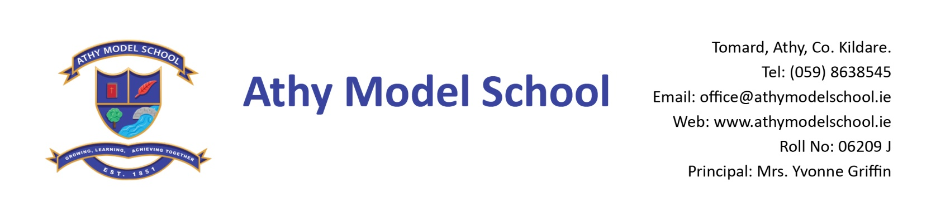

2nd Class Book List 2022-2023

English
Over the Moon: Skills Book 1st Class (Gill)
Sounds Like Phonics Activity Book D ( CJ Fallon)
Just Handwriting Cursive Handwriting Programme for first class (educate.ie)
(We begin cursive writing in 1st class, therefore 2nd class use the 1st class book)

Irish
Bua na Cainte 1

Maths
Busy at Maths 2 (CJ Fallon)
Work it Out 2nd class (educate.ie)
Tables book (C.J. Fallon) You can use table book from last year

Copies: The school will supply all copies. You will be billed for them in September.

PE: Non- marking trainers

Grass Play: Waterproof runners/wellies (to be kept in school) Please supply a drawstring bag to hold them in

Art: Old adult sized t-shirt

Please supply:

4 A4 zip wallets (mesh only)
2 B5 zip wallets (mesh only)
1 scissors
Long ruler, pencils, colouring pencils, rubbers, sharpeners, pencil case
2 Pritt sticks: to be replenished when necessary
3whiteboard markers: to be replenished when necessary
Whiteboard Rubber
Reusable drinks container
Hand towel (with hook/tag for hanging on bathroom hooks)

Please
Label all of the above clearly with child’s name (including colouring pencils)
Name all textbooks in pencil only on inside cover (just in case the wrong book has been purchased)

