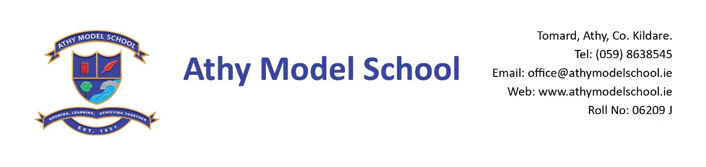
Book Rental Scheme- 3rd Class Book List 2022-2023
English
Spellings for Me Workbook (Online programme) The school will purchase this and you will be billed for it in September

Gaeilge
Seo Leat 3 – Third Class Book (C.J. Fallon)
Rírá 3 (CJ Fallon)

Maths
Busy at Maths 3 (C.J. Fallon)
New Wave Mental Maths Workbook 3rd Class (Prim Ed)
Number Facts 3 (Edco)
Tables Book (CJ Fallon) Please keep your tables book from last year

SESE
Let’s Discover! Third Class Science Journal (CJ Fallon)

Copies: The school will supply all copies. You will be billed for them in September.

PE Non marking runners. Also, a spare/ old pair of runners to be kept in school.

Grass Play: Waterproof runners/wellies (to be kept in school) Please supply a drawstring bag to hold them in

Art Old adult sized t-shirt

Please supply:
2 A4 zip wallets (mesh only)
Long ruler, pencils, markers, colouring pencils, rubbers, sharpeners
3 Pritt sticks: to be replenished when necessary
Set of whiteboard markers: to be replenished when necessary
1 scissors
1 A4 Hardback book
1 Ring Binder Folder, dividers, 20 poly pockets, address labels.
Reusable drinks container
Hand towel: with hook/tag for hanging on bathroom hooks

Please
Label all of the above clearly with child’s name (including colouring pencils)
Name all textbooks in pencil only on inside cover (just in case the wrong book has been purchased)
Pupils will label all copies in September.

