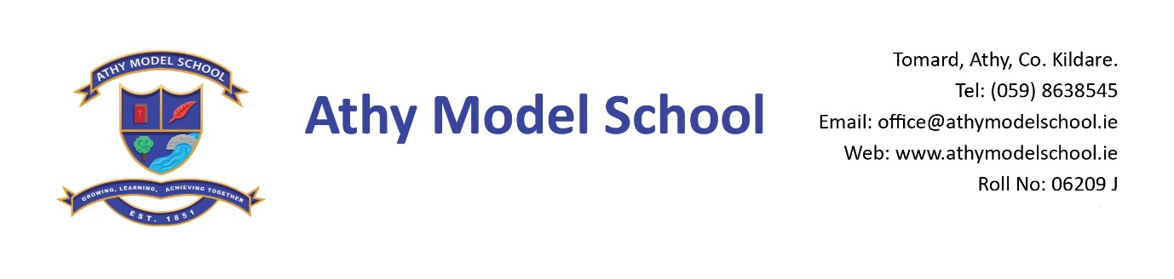
Book Rental Scheme: 4th Class Book List 2022-2023
English
Spellings for Me Workbook (Online programme) The school will purchase this and you will be billed for it in September

Gaeilge
Rírá 4 (C.J. Fallon)
Seo Leat 3 – Third Class (C.J. Fallon)

Maths
New Wave Mental Maths Workbook 4th class (Prim-Ed)
Number Facts 4 (Edco)
Tables Book (please keep your tables book from last year)
Calculator

SESE
Let’s Discover! Third Class Science Journal (CJ Fallon)

Copies: The school will supply all copies. You will be billed for them in September.

PE: Non marking runners. Also, a spare/ old pair of runners to be kept in school.

Grass Play: Waterproof runners/wellies (to be kept in school) Please supply a drawstring bag to hold them in

Art: Old shirt
Please supply:

Blue Frixion erasable pen: to be replenished when necessary. (Available from Tesco & Easons)
2 A4 zip wallets (mesh only)
Long ruler, pencils, markers, colouring pencils, rubbers, sharpeners
3 Pritt sticks: to be replenished when necessary
Set of whiteboard markers: to be replenished when necessary
1 scissors
1 Ring Binder Folder, dividers, 20 poly pockets, address labels.
Reusable drinks container
Hand towel: with hook/tag for hanging on bathroom hooks

Please
Label all of the above clearly with child’s name
Name all textbooks in pencil only on inside cover (just in case the wrong book has been purchased)
Pupils will label all copies in September.

