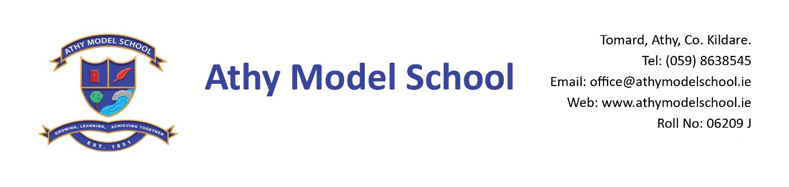
Book Rental Scheme- 6th Class Booklist 2021-2022

English
Spellbound F (Folens)
Educate.ie Just G-r-rammar 5th Class book

Gaeilge
Seo Leat 5 (CJ Fallon)
RíRá – Rang a Sé (CJ Fallon)

Maths
New Wave Mental Maths 6th class (Prim Ed)
Tables Champion 6th Class (Educate.ie)
Tables Book (CJ Fallon) – Please use table book from last year
Geometry set
Calculator

SESE
Let’s Discover! Fifth Class - Science Journal (CJ Fallon)

Copies: The school will supply all copies. You will be billed for them in September.

PE: Non-marking runners only Art: An old adult sized t-shirt

Grass Play: Waterproof runners/wellies (to be kept in school) Please supply a drawstring bag to hold them in

Please supply:

Blue & Black Frixion erasable pen – to be replenished when necessary. (Available from Tesco & Easons)
1 USB Memory Stick (For project work etc. – any size)
2 A4 zip wallets (mesh only)
1 A4 foolscap lined paper
Set of whiteboard markers: to be replenished when necessary
Red biro, Long ruler, pencils, markers, colouring pencils, rubbers, sharpeners
3 Pritt sticks: to be replenished when necessary
1 Safety scissors
1 Ring-binder Folder, dividers, 20 poly pockets, address labels
Reusable drinks container
Hand towel: with hook/tag for hanging on bathroom hooks

Please
Label all of the above clearly with child’s name
Name all textbooks in pencil only on inside cover (just in case the wrong book has been purchased)
Pupils will label all copies in September.

