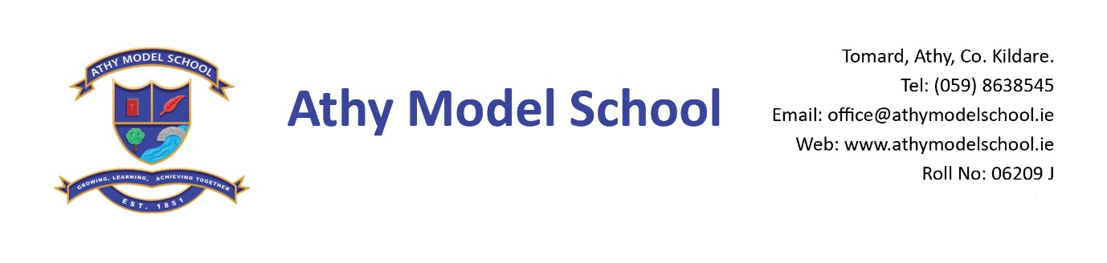
Junior Infant Booklist 2022-2023
English

Over the Moon: Skills Book Senior Infants (Gill)
Just Handwriting: Pre-cursive Handwriting programme for Junior Infants (educate.ie)
Just Phonics Junior Infants 42 sounds (educate.ie)

Maths

Busy at Maths Junior Infants (CJ Fallon)

Copies: The school will supply all copies. You will be billed for them in September.

PE Non- marking trainers – Velcro fastening only

Grass Play: Waterproof runners/wellies (to be kept in school) Please supply a drawstring bag to hold them in

Art Old adult sized t-shirt (with no buttons/fasteners)

Please supply:

4 A4 zip wallets (mesh only)
2 A4 document folders
1 B5 zip wallet (mesh only)
Pencil Case (one where pencils can be placed in easily & quickly!)
Junior Grip handwriting pencils
Crayon Twistables
Erasers, sharpeners
3 Pritt sticks: to replenished when necessary
3 Whiteboard markers: to replenished when necessary
Whiteboard rubber
2 Scissors: please keep one at home
Reusable drinks container
Hand towel: with hook/tag for hanging on bathroom hooks

Please
Label all of the above clearly with child’s name (including colouring pencils)
Name all textbooks in pencil only on inside cover (just in case the wrong book has been purchased)

